B3U7

Is Fashion Art?  注意有争议，有不同立场的一些表达方法。可以用于写作。  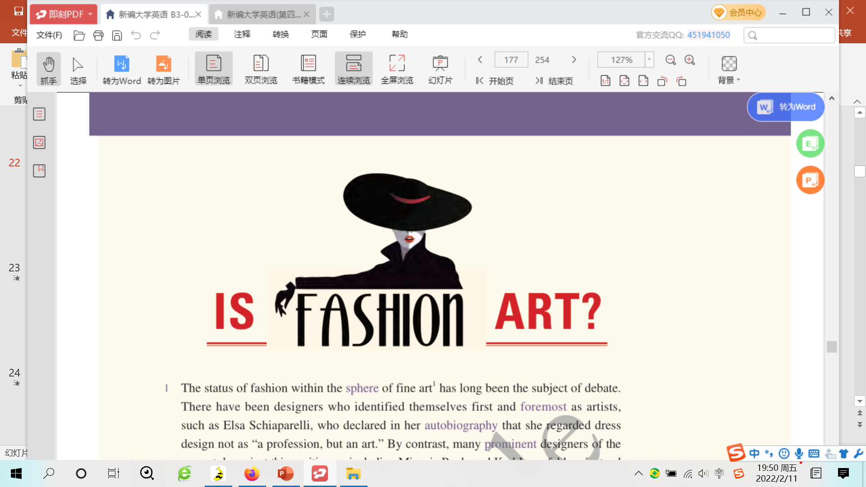  [1] The status of fashion within the sphere of fine art has long been the subject of debate. There have been designers who identified themselves first and foremost as artists, such as Elsa Schiaparelli, who declared in her autobiography that she regarded dress design not as "a profession, but an art." By contrast, many prominent designers of the present day reject this position — including Miuccia Prada and Karl Lagerfeld — instead viewing fashion and art as their own separate, if highly complementary, realms. In fact, Yves Saint Laurent believed there to be such a large gap between the two fields that he once lamented that, despite his legendary achievements as a fashion designer, "I am a failed painter."  [2] In 1983, this occasional dispute was brought to the forefront of art criticism and scholarship when The Metropolitan Museum of Art's Costume Institute held an exhibition of Saint Laurent's designs. Displaying the iconic clothes in the same manner and context as masterpieces by Picasso and Monet angered many critics, who were forced to question whether an "applied" or "decorative" art should be elevated to the same platform as fine art.  [3] From one point of view, the main differences between fashion and art could be found in their utility and temporality. Fashion is constrained by certain factors, including wearability and the specific contours of the human body, for instance. It has a clear commercial value, priced as a cross-function of the cost of goods and brand perception. Fashion is ever-evolving, frequently changing based on trends. Those considerations, one could argue, keep fashion distinct from art, in which economic considerations in general are seen as much less important — art is created regardless of its economic value. And the nonutility of art is a key factor that differentiates it from fashion, as is the fact that its value increases over time.  [4] However, in the real art world — and in the most avant-garde corners of fashion — these distinctions have never been so clear-cut, and today they're increasingly being blurred. Fashion designers like Rei Kawakubo have rebelled against the format of the human body, cutting clothes with unnatural shapes that suggest alternative physical possibilities. Fashion has increasingly dominated fine art museums: The Metropolitan Museum of Art's 2011 retrospective "Alexander McQueen: Savage Beauty" was one of the most popular and widely attended exhibitions in the museum's history （video）. And anyone who doesn't believe that the most significant designer clothes do increase in value has never attended a fashion auction, such as last November's Vintage Couture sale at Christie's, London, where a 1939 black velvet evening jacket by Schiaparelli was sold for $117, 200.  - Just as fashion is following art, art, too, is steadily adopting characteristics typical of fashion. As art economist Clare McAndrew noted in her book The Art Economy, "no matter how highly valued art is in society, there is no escaping the fact that it is produced, bought, and sold by individuals and institutions working within an economic framework inescapable from material and market constraints," a fact that is mainly a byproduct of an increasingly global art market. Artists today have become brand names, with many investors looking less at the aesthetic or formal qualities of an artwork and instead examining an artist's sales history and "brand value." They just look at each piece of art as an investment in the same way someone might buy stocks and shares in a company.  - In turn, many contemporary artists have made art's function as a market commodity a core aspect of their work. Leveraging their brand identities, artists have often partnered with fashion designers to create wildly popular clothing collaborations, such as Murakami's Louis Vuitton bags. And anyone who doesn't believe that art follows trends has never toured an art fair, where common approaches to a perceived opening in art history often lead to a profusion of similar objects made by artists all over the world.  [7] Considering the changing dynamics of the art and fashion worlds — particularly over the past 50 years — the distinctions between fashion and art in the traditional sense become almost nonexistent. So ... fashion is clearly art, right? Well, in my view, not quite. Fashion and art share more of a symbiotic relationship, as two different means of creative self-expression that profit from frequent interchange. There is no doubt that fashion demands a rightful place in the museum, and should be valued for its contribution to our visual culture. Fashion shows today are so elaborate and conceptual that it's difficult not to consider them a form of performance art. I could not argue against anyone who said that certain styles from avant-garde designers like Alexander McQueen are true works of art.  [8] Yet, the intrinsic difference between fashion and art remains, in terms of utility — just as there is a distinction between design, where an object is created to fulfill a functional need, and art, where artworks largely fulfill non-functional (spiritual, for instance) needs. There's a reason fashion designers are called "designers," after all. However, Karl Lagerfeld may have put it best when he said how closely connected the two are: "Art is art. Fashion is fashion. However, Andy Warhol proved that they can exist together." | 时尚是艺术吗？  1 时尚在艺术界的地位一直以来都是一个饱受争议的话题。有些设计师首先将自己定位为艺术家，比如艾尔莎·夏帕瑞丽。她在自传中声明，她认为服装设计并不是“一种职业，而是一门艺术”。相反，当下许多杰出的设计师——包括缪西娅 • 普拉达和卡尔 • 拉格斐——都拒绝接受这一立场，而是将时尚和艺术视为两个独立的领域，虽然两者是高度互补的关系。实际上，伊夫 • 圣 • 罗兰认为这两个领域之间存在着巨大的差距，以至于他尽管作为时装设计师取得了传奇成就，但也曾伤感地说：“我是一名失败的画家。”  2 1983年，当美国大都会艺术博物馆的服装艺术部举办圣 • 罗兰的设计展时，这一偶尔出现的争议成了艺术评论界和学术研究界关注的焦点。这场展览以与展出毕加索和莫奈的杰作相同的方式和环境来展示这些经典服饰。这一做法激怒了许多评论家，他们不禁质疑“应用”艺术或“装饰”艺术是否应该被提升到与艺术相同的地位。  3 从某种角度来看，时尚与艺术之间的主要区别在于它们的实用性和时效性。时装会受某些因素的制约，比如穿着性能和人体的特定轮廓。时装具有明显的商业价值，它的定价与商品的成本和品牌认知度有关。时尚一直在不断地发展，并会根据潮流频繁变化。人们可以认为，考虑到这些，时尚与艺术便是两个截然不同的领域了。与时尚相比，在艺术中，经济上的考虑通常被认为不那么重要——艺术创作是不考虑经济价值的。艺术的非实用性是使其与时尚区分开来的一个关键因素，正如艺术会随着时间的推移而增值这个事实能将两者区分开来一样。  4 然而，在真实的艺术界以及在时尚最前卫的地方，时尚与艺术之间的区别一直都不那么明确，并且如今两者之间的边界正变得越来越模糊。川久保玲等时装设计师违反了根据身体曲线设计服装的做法，以非常规的形状来裁剪衣服，暗示了衣服轮廓的其他可能性。时尚逐渐主导了艺术博物馆：美国大都会艺术博物馆在2011年举办的“亚历山大 • 麦昆：野性之美”回顾展是该博物馆历史上举办过的最受欢迎且参观人数最多的展览之一。要是有谁不相信最有名的设计师所设计的衣服会随着时间增值，是因为他们从未参加过时装拍卖会。比如在去年11月伦敦佳士得拍卖行举办的古董高级服装拍卖会上，一件由夏帕瑞丽在1939年设计的黑丝绒晚礼服上装以117,200美元的价格被拍出。  5 正如时尚在追随艺术的脚步，艺术也正在逐渐呈现时尚所具有的典型特征。正如艺术经济学家克莱尔 • 麦克安德鲁在她的《艺术经济》一书中所指出的那样：“无论艺术在社会中有多么被珍视，一个不可逃避的事实是：艺术是被那些处于经济体制中的个人和机构创造、购买和售卖的，而经济体制摆脱不了物质和市场的制约。”这一事实主要归因于日益全球化的艺术品市场(注意这个表示因果的翻译方法)。如今的艺术家自己已经成了品牌，许多投资者较少关注艺术品美学上或形式上的特质，而是考察艺术家的销售历史和“品牌价值”。他们将每一件艺术品仅仅视为一项投资，就如同有人可能会购买某公司的股份与股票一样。  6 相应地，许多当代艺术家们已经将艺术品的市场商品属性作为他们作品的核心方面。艺术家们利用他们的品牌身份，经常与时装设计师合作来推出广受欢迎的联名服饰，比如村上隆设计的路易 • 威登包。任何一个不相信艺术会跟随潮流发展的人之所以这样想，是因为他从未参观过艺术博览会。在那里，人们采取一些常用的做法来抓住艺术史上能窥见的机会，而这些做法通常会导致全世界的艺术家创作出大量相似的作品。  7 鉴于艺术界和时尚界的动态变化——尤其是在过去的这五十年里——传统意义上的时尚和艺术之间的区别变得几乎不存在了。因此……时尚很明显是一种艺术了，对吧？好吧，在我看来，不完全是这样。艺术和时尚是创造性地表达自我的两种不同方式，它们受益于彼此频繁的交流，它们之间更多的是一种共生关系。毫无疑问，时尚需要在博物馆中占据一席之地，并且它应该因其对我们的视觉文化所做出的贡献而受到重视。当今的时尚秀是如此精致和概念化，以至于人们很难不将其视为表演艺术的一种形式。如果有谁说亚历山大 • 麦昆等前卫设计师设计的某些款式是真正的艺术品，我是无法反驳的。  8 然而，就实用性而言，时尚和艺术之间的本质区别依然存在。这就如同设计和艺术之间是有区别的。在设计中，一件物品被设计出来是为了满足人们的某种功能性需求；在艺术中，艺术品主要是满足人们的非功能性需求（比如精神需求）。毕竟，时装设计师被称为“设计师”是有原因的。然而，当卡尔 • 拉格斐谈及两者的关系有多么密切的时候，他说的也许是最合理的：“艺术是艺术。时尚是时尚。然而，安迪 • 沃霍尔证明了两者是可以共存的。”

